SALES QUOTATION – SQT.21.22.0021R3

Reliance Industries Ltd. Date – 06/07/2021
Project – Vrindavan, Mumbai
Product – Automatic Sliding and Stacking Platform of Swimming Pool.

Thank you for your opportunity and trust shown on “NIHVA” your preferred partner for innovative solutions. This has reference to your above-mentioned requirement, please find below our Solutions.
Operational Technique
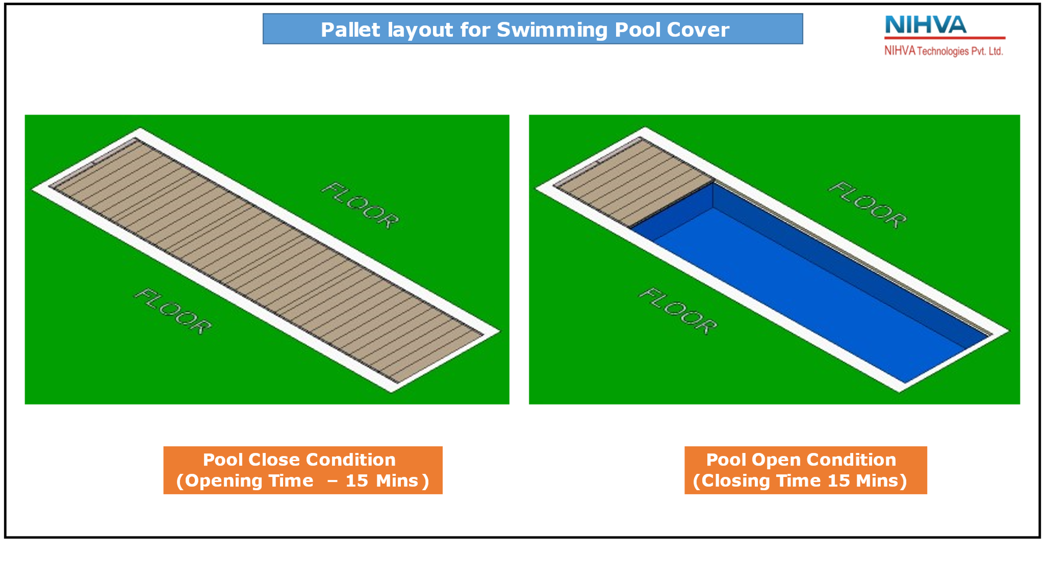
The whole framework is made of SS 316L grade. The pool and pit are covered by SS 316L structure which is divided in 6 pallets. These pallets are going to slide with the help of induction motor and gearbox toward the pit. One by one they will get stacked in the pit and pit assembly will move vertically down each time pallet enters. The system does not depend on cables, hydraulic, pneumatic etc. It only works on electrical system with all logic connected through control panel.

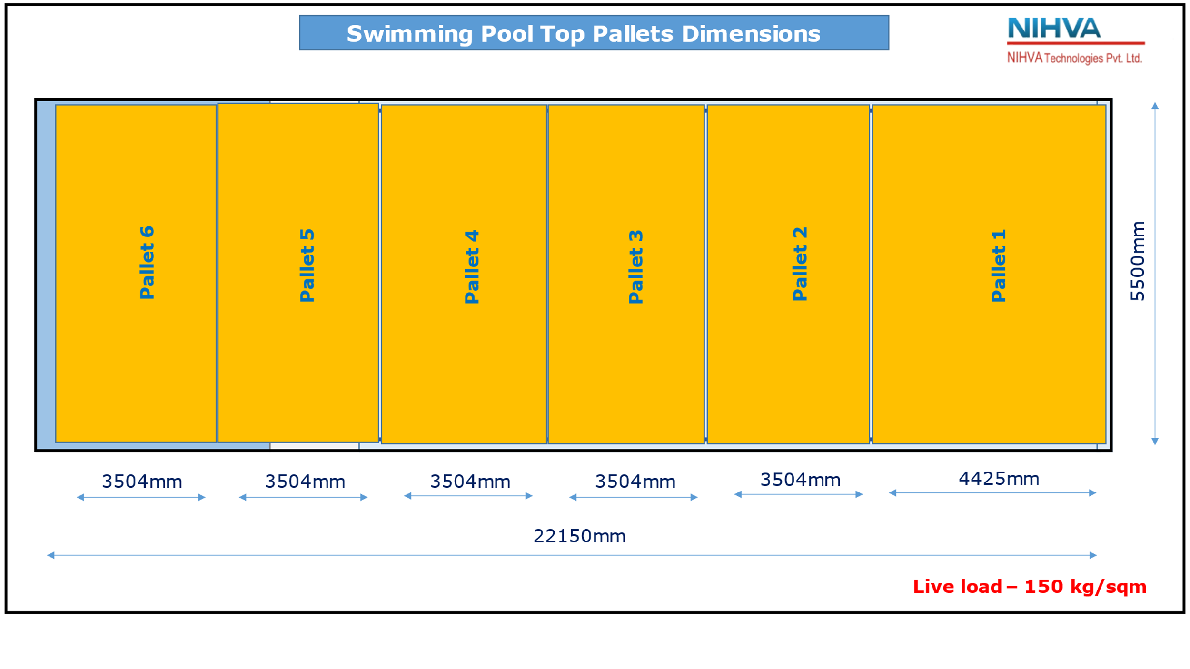
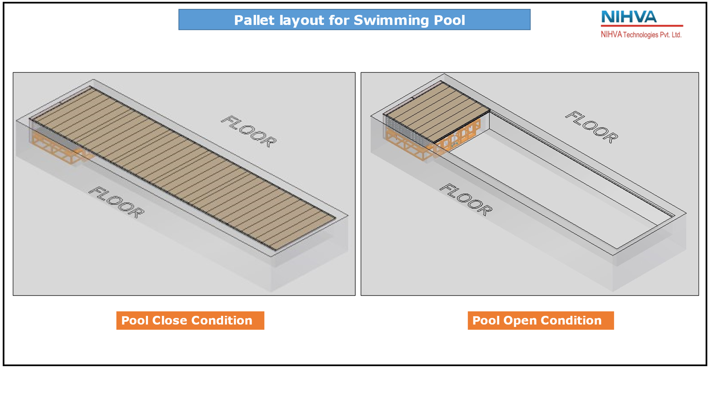
System Representation

Scope of work -

- Design, Mfg, Supply, Installation and Commissioning of Automatic Sliding and Stacking Platform of Swimming Pool.

Technical Functionality

The Sliding and stacking deck system are divided into 6 pallets. Pallet 1 to 5 covers the pool and pallet 6 is above the pit.

- Pallet 1 is of 4425mm X 5500mm
- Pallet 2 to 6 are of 3504mm X 5500mm.

In the pit we have 4 structures.
- SS 316L Bottom Frame
- SS 316L Top Frame
- SS 316L End support unit
- SS 316L Roller support unit

The process starts by the vertically downward movement of Frame assembly in pit by a pitch of 200 mm. As it moves down the pallet 6 will go down and pallet 5 starts sliding toward the pit direction. This movement is due to the induction motor which starts the rotation of rollers mounted on roller support unit by inline helical gearbox and further connected by heavy duty bevel type gearbox.

The pallet 5 will come at stop at a specific position with the help of end support unit and sensors. All the pallet are interconnected so now pallet 4 comes on the position of pallet 5. Again, the Frame assembly pit moves vertical down and pallet 4 starts coming toward the pit. Simultaneously the pallet 3, pallet 2 and pallet 1 moves as they all are interconnected by hook rod setting. In next stage the pallet 3 will move toward the pit and in similar manner pallet 2 will also settles down in the pit. In the end pallet 6 which is the biggest pallet will move towards the pit and get levelled with the adjoining surface.

The whole movement is controlled with the help of Control unit and programming defining the path of the system. It takes 15 mins to complete this cycle. The shaft is supported through with the help of Plummer block placed equidistance to each other. The vertical up and down movement is done with another induction motor connect to bevel gearbox which indirectly connects to worm type screw that are placed around the four edges of pit. The rollers are placed at the bottom and at the side for ease in the movement.

To cover the pool, again the motor start reverses rotation and the roller unit push the pallet 6 toward the pool. With the help of control logic, once the pallet 6 stop at defined position and pit unit moves upward while locking the pallet 5 with pallet 6. In similar manner all the pallet comes out one by one and get interlocked to each other. In this way pool get covered.

The shop drawings along with tech specs will be submitted for approval after receipt of firm P.O.

Commercial Details –

PRODUCT | SIZE | QTY | SUPPLY PRICE | INSTALLATION PRICE | TOTAL SUPPLY & INSTALLATION
SLIDING AND STACKING DECKING FOR POOL | 5500mm(W) X 22150mm(L) | 1 | ₹ 1,83,00,000 | ₹ 7,25,000 | ₹ 1,90,25,000
P&F CHARGES | 3% |  |  |  | ₹ 5,70,750
TOTAL WITHOUT TAX |  |  |  |  | ₹ 1,95,95,750
GST | 18% |  |  |  | ₹ 35,27,235
TOTAL WITH TAX |  |  |  |  | ₹ 2,31,22,985
Excluding Transportation + Unloading material at site required floor + Lifting Equipment if any

General Terms & Conditions-
  - NIHVA is going to use external structural consultant for structural pallet stability.
  - Make and Model of electrical components would be finalized with the consent of client’s site team from the suggestion provide by NIHVA team.
  - Multiple site visit will be going to carried out at different stages of project by NIHVA.
  - WBS to be submitted by NIHVA after receival of PO.
  - FAT shall be carried out before dispatch.
  - Continuous uninterrupted access to installation section or as agreed separately.
  - Provision of 230 Volt power supply (by others) for hand tools.
  - A dry and secure area, not in direct sunlight, is to be provided for storage of the product components.
  - Access to site between 7 am to 12 pm six days per week. If this is not possible, the installation programme may require amending.
  - Any storage costs for materials due to delays outside of NIHVA, will be in Client Scope.
  - Unloading of material and internal movement of material on site to the installation area is under Client scope.
  - The project time indicated does not take into account adverse weather conditions, pandemic situation, local Govt restrictions that may prevent safe and efficient working practices. We reserve the right to extend the period accordingly.
  - Any passes required for the project, are the responsibility of the Customer and Contractor and must be available, before commencement of the installation. Any delays caused by the non-availability of passes, will be charged accordingly.

Sr. No | Remark
1 | Secured and fully covered Store area to keep the material | In Client Scope
2 | Scaffolding/Hydra/Crane/Forklift etc - Required for Installation at Site | In Client Scope
3 | Electrical Supply on the site single phase/three phase points at different places. | In Client Scope
4 | Any civil / masonry/structural work required | In Client Scope
5 | All structure support required | In Client Scope
6 | In Case of any changes in the layout as per site requirements after the shipment of material, the additional quantities and the wastage. | In Client Scope
7 | Conduits, Cables required | In Client Scope

Terms & Conditions-

Price: Ex Works Pune
Delivery: Approximately 15-16 weeks from having received official order confirmation + advance payment + signed & stamp drawing approval
(Subject to - Lead time might be impacted due to current crisis of Covid -19 & DELTA +)
Supply Payment:
25% Advance along with confirmed Purchase order on Supply price
10% after Shop drawing approval
20% after testing of prototype sliding mechanism (partially)
20% before SS procurement
20% before dispatch and FAT
5% after completion of installation
Advance BG will be applicable only if min. 60% advance approved till first prototype inspection and testing else for 25% no ABG
Installation Payment:
50% of Installation charges before mobilization of team
50% of Installation charges after Installation, commissioning & testing
Validity: Validity of Offer is 10 days from the date of quotation.
Warranty: from date of supply -
2 Years for manufacturing defect on the structural system
1 Year on Mechanical drive system and for all electrical components
AMC: 8.5% of the product value for each year till the time period of 3 years
Revision of AMC value applicable after completion of 3 years
Design Clause
NIHVA shall be deemed the authors of their respective concept and drawings with reserved rights, including copyrights. It shall not be used by the owner for future additions or alterations to this Project or for another project or should not copied at any other future project or should not transfer or copied by anyone.

Compensation Clause
Please note that in the event the buyer cancels an order, after the order is confirmed to us, it is binding to the buyer to pay NIHVA a compensation of 25% of order value.

Please feel free to Contact us for any further Clarification Information in this Concern.

With Best Regards,

Ajay Khanna
+91-98181 85152
TI Tensile Structures

Vijay Tarak
+91-85510 33333
NIHVA Technologies Pvt. Ltd.

